**PIZZA_SALES SQL (SQL SERVER) QUERIES**

KPI’s

1. Total Revenue

select round(SUM(total_price),2) as Total_Revenue from pizza_sales;

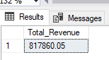

2. AVERAGE ORDER VALUE

select round(SUM(total_price) / COUNT(distinct order_id),2)

as Avg_value from pizza_sales;

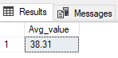

3. TOTAL PIZZA SOLD

select sum(quantity) as Total_Pizza_Sold from pizza_sales

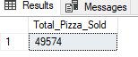

4. TOTAL ORDERS

select COUNT(distinct order_id) as Total_Orders from pizza_sales

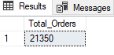

5. AVERAGE PIZZA PER ORDER

select cast(cast(SUM(quantity) as decimal (10,2)) /

cast(COUNT(distinct order_id) as decimal (10,2))

as decimal (10,2)) as Avg_Pizza_per_order from pizza_sales

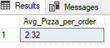

B. Chart Requirements

1. Daily Trend for Total Orders

select DATENAME(DW,order_date) as Order_day, COUNT(distinct order_id)

as Total_Orders from pizza_sales group by DATENAME(DW,order_date);

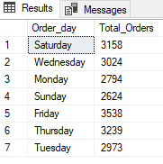

2. Monthly Trend for Total Orders

select DATENAME(month, order_date) as Month_name,

COUNT(distinct order_id) as Total_orders from pizza_sales

group by DATENAME(month, order_date);

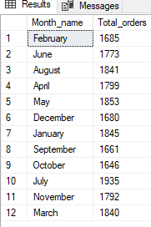

3. Hourly Trend for Total Orders

select DATEPART(HOUR, order_time) as Total_hours,

COUNT(distinct order_id) as Total_orders from pizza_sales

group by DATEPART(HOUR, order_time);

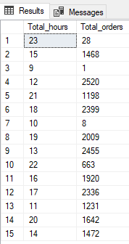

4. Percentage of Sales by Pizza Category

select pizza_category, cast(sum(total_price) as decimal (10,2)) as Total_Sales,

cast(SUM(total_price) * 100 /

(select SUM(total_price) from pizza_sales

where MONTH(order_date) = 1) as decimal (10,2)) AS PCT from pizza_sales

where MONTH(order_date) = 1

group by pizza_category;

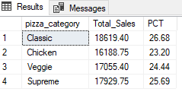

5. Percentage of Sales by Pizza Size

select pizza_size, CAST(SUM(total_price) AS Decimal (10,2)) as Total_Sales,

cast(SUM(total_price) * 100 /

(select SUM(total_price) from pizza_sales

where datepart(quarter, order_date) = 1) as decimal (10,2)) AS PCT from pizza_sales

where datepart(quarter, order_date) = 1

group by pizza_size;

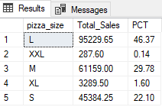

6. Top 5 Best Sellers by Revenue

select top 5 pizza_name, SUM(total_price) as Total_Revenue

from pizza_sales group by pizza_name order by Total_Revenue desc;

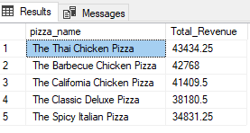

7. Top 5 Best Sellers by Total Quantity

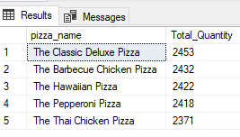

select top 5 pizza_name, SUM(quantity) as Total_Quantity from

pizza_sales group by pizza_name order by Total_Quantity desc;

8. Top 5 Best Sellers by Total Orders

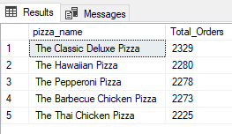

select top 5 pizza_name, COUNT(distinct order_id) as

Total_Orders from pizza_sales

group by pizza_name order by Total_Orders desc;

9. Bottom 5 Top Sellers by Revenue

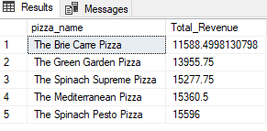

select top 5 pizza_name, SUM(total_price) as Total_Revenue

from pizza_sales group by pizza_name order by Total_Revenue asc;

10. Bottom 5 Sellers by Total Quantity

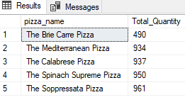

11. Bottom 5 Top Sellers by Total Orders

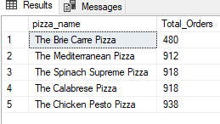

select top 5 pizza_name, COUNT(distinct order_id) as

Total_Orders from pizza_sales

group by pizza_name order by Total_Orders asc;